6.3 Homework 5: Engagement and Peer Feedback on Responsible and Ethical AI Use

Homework 5 (Weeks 5-9) Engagement and Peer Feedback on Responsible and Ethical AI Use
Purpose of Engagement and Peer Feedback
This activity aims to:
- Enhance evaluative judgment by critically assessing peer work.
- Improve company analysis skills in finance assignments.
- Foster responsible and ethical AI use, comparing traditional and AI-assisted methods.
- Encourage collaboration and discussion on financial decision-making.
This aligns with real-world finance practices, where analysts collaboratively review and refine financial reports using both AI and traditional methods.
The engagement in this activity will be assessed as part of the homework, class participation, and engagement (Weeks 5 – 9).

Complete Phase 1 (report submission on task 1 & 2) of the Engagement and Peer Feedback on Responsible and Ethical AI use
Phase 1: Controlled AI Engagement Activity (Weeks 5-7)
- Group Division:
In week 5, each group (four members) is split into two sub-groups (i.e. sub-groups A and B). For example, group 6 will be divided into groups 6A and 6B). One sub-group completes Group Assignment components 1 and 2 (Acquiring Firm Overview and Target Firm’s Profile and Market Outlook[1]) in the group project report guide using traditional, non-AI methods. The other sub-group completes the same task with AI support. Those who use AI should carefully note the AI platform and all the prompts used with the relevant outputs to help complete tasks. This note should not be included in the submission in week 7, but will be used for discussion in Phase 3 (week 9).
- Submission of the target company analyses:
Each sub-group submits a written report (3-4 pages) summarising its acquiring and target firm analyses to Feedback Fruits on Canvas by 4:00PM Friday 12 September (Week 7). Please note this submission is for peer review and feedback ONLY and will not be counted towards the final marks of the group written report submitted at the end of the semester. Groups can revise and update the analysis after receiving feedback to include in the final report submitted for grading.
[1] Refer the FNCE 90012_Group Assignment SM2 2025 Guide (page 2) for the task details

Further guidance on AI use
Using GenAI ethically and effectively: Study skills

Feedback Fruits

nstructions by teacher
Phase 1: Controlled AI Engagement Activity (Weeks 5-7)
- Group Division:
In week 5, each group (four members) is split into two sub-groups (i.e. sub-groups A and B). For example, group 6 will be divided into groups 6A and 6B). One sub-group completes Group Assignment components 1 and 2 (Acquiring Firm Overview and Target Firm’s Profile and Market Outlook [1]) in the group project report guide using traditional, non-AI methods. The other sub-group completes the same task with AI support. Those who use AI should carefully note the AI platform and all the prompts used with the relevant outputs to help complete tasks. This note should not be included in the submission in week 7, but will be used for discussion in Phase 3 (week 9).
- Submission of the target company analyses:
Each sub-group submits a written report (3-4 pages) summarising its acquiring and target firm analyses to Feedback Fruits on Canvas by 4:00PM Friday 12 September (Week 7). Please note this submission is for peer review and feedback ONLY and will not be counted towards the final marks of the group written report submitted at the end of the semester. Groups can revise and update the analysis after receiving feedback to include in the final report submitted for grading.
Phase 2: Blind Peer Review Process (Week 8)
Groups will be randomly allocated to review another group’s submission. Peer review will take place in teaching week 8. Each group will assess the assigned report using the structured rubric. Peer feedback must be provided via Feedback Fruits on Canvas by 4:00PM Friday 19 September (Week 8).
Phase 3: Structured Reflection & Discussion (Week 9)
In week 9 lecture, there will be an in-class discussion to compare AI-assisted vs. traditional financial analysis. Debate on responsible use of AI, over-reliance on AI, accuracy, and ethical concerns. Identify key takeaways for financial decision-making.
Peer Review Guidelines
Providing Constructive Feedback
Your feedback should be specific, constructive, and professional. Use the following structure:
- Strengths (What was done well?)
- Areas for Improvement (What could be better?)
- Do you think this report was completed with AI support? Justification
- Rating the Submission
Rate the submission on a scale of 1-5 (1 lowest - 5 highest) in the following areas:
Comments (Justify Your Rating)
- Clarity and Organization
- Depth of Analysis
- Use of Data & Financial Ratios
- Justification & Supporting Evidence
- Actionable Insights & Recommendations
Self-Reflection should address these following points:
- Which AI tools did you use and what prompts?
- Which approach (AI vs traditional) yielded more insightful results?
- What are the suggested improvements based on peer feedback?
- What tasks can AI help with—and what can it not?
- How were accuracy, clarity, and ethical use of AI addressed?
- What skills were most helpful in achieving a quality analysis?
- What did you learn from peer feedback and team collaboration?
[1] Refer to the FNCE 90012_Group Assignment SM2 2025 Guide (page 2) for the task details).
Show less
Submission per group

Instructions by teacher
Each sub-group submits a written report (3-4 pages) summarising its acquiring and target firm analyses to Feedback Fruits on Canvas by 4:00PM Friday 12 September (Week 7). Please note this submission is for peer review and feedback ONLY and will not be counted towards the final marks of the group written report submitted at the end of the semester. Groups can revise and update the analysis after receiving feedback to include in the final report submitted for grading.
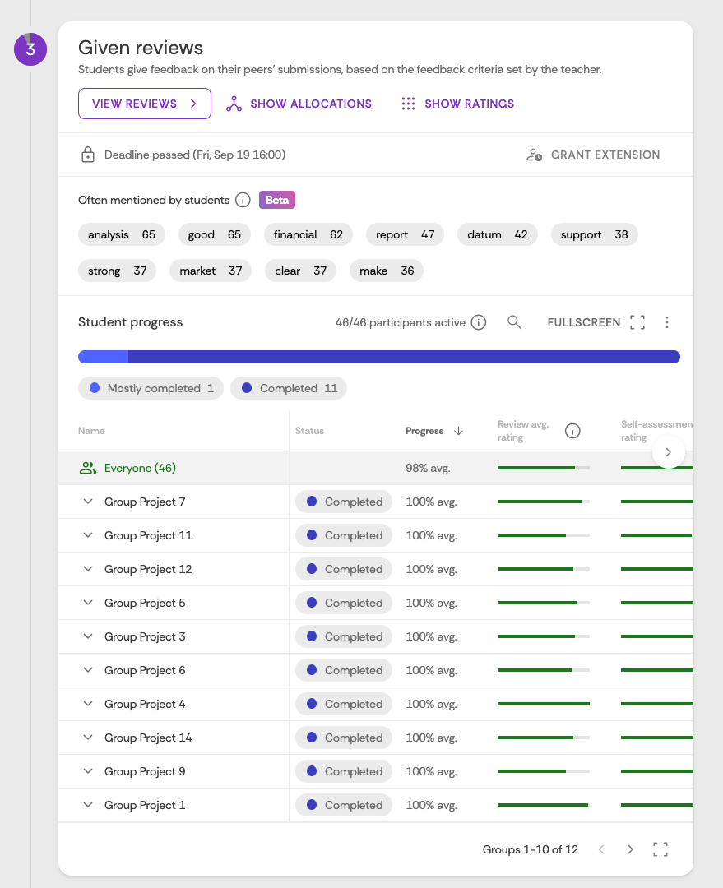

Reflections
Instructions by teacher
Self-Reflection should address these following points:
- Which AI tools did you use and what prompts?
- Which approach (AI vs traditional) yielded more insightful results?
- What are the suggested improvements based on peer feedback?
- What tasks can AI help with—and what can it not?
- How were accuracy, clarity, and ethical use of AI addressed?
- What skills were most helpful in achieving a quality analysis?
- What did you learn from peer feedback and team collaboration?
