University of Melbourne
Sexual Misconduct Annual Report 2024

Content Warning
This report contains information about sexual assault and sexual harassment which may be distressing. If you would like to speak to someone for support, please contact the following internal or external supports.
Safer Community Program - safercommunity.unimelb.edu.au Phone: +61 3 9035 8675
Email: safer-community@unimelb.edu.au
Sexual Assault Crisis Line Victoria - Phone: 1800 806 292
1800 RESPECT - Phone: 1800 737 732
University of Melbourne Counselling & Psychological Services - services.unimelb.edu.au/counsel
Phone +61 3 8344 6927 Email: caps-reception@unimelb.edu.au

Acknowledgement of Country
The University of Melbourne acknowledges the Traditional Owners of the unceded land on which we work, learn and live: the Wurundjeri Woi-wurrung and Bunurong peoples (Burnley, Fishermans Bend, Parkville, Southbank and Werribee campuses), the Yorta Yorta Nation (Dookie and Shepparton campuses), and the Dja Dja Wurrung people (Creswick campus).
The University also acknowledges and is grateful to the Traditional Owners, Elders and Knowledge Holders of all Indigenous nations and clans who have been instrumental in our reconciliation journey.
We recognise the unique place held by Aboriginal and Torres Strait Islander peoples as the original owners and custodians of the lands and waterways across the Australian continent, with histories of continuous connection dating back more than 60,000 years. We also acknowledge their enduring cultural practices of caring for Country.
We pay respect to Elders past, present and future, and acknowledge the importance of Indigenous knowledge in the Academy. As a community of researchers, teachers, professional staff and students we are privileged to work and learn every day with Indigenous colleagues and partners. In making this Acknowledgment of Country we commit to respectful and responsible conduct towards all others according to the Traditional lores of this land, particularly at times of formal ceremony.

Acknowledgement of Victim-Survivors
We recognise victim-survivors who have experienced sexual assault or harassment, and the courage of those who have come forward to speak to staff at the University and seek support, and we stand in solidarity with those who have not.
We acknowledge that evidence in Australia tells us that although anyone can experience sexual assault or sexual harassment, it is disproportionately experienced by women, individuals from the LGBTIQA+ community, people from culturally and linguistically diverse backgrounds, and those with disabilities. Aboriginal and Torres Strait Islander peoples carry a disproportionate burden of sexual assault and harassment.
We recognise that the data contained in this report do not describe the suffering that sits behind the numbers. Sexual violence has physical, psychological, and emotional impacts on members of our community. We hope that by openly reporting these data, the University and its community can see and better understand the incidence of sexual misconduct, its consequences when reported, and our ongoing efforts to prevent it.

Terminology used by the University of Melbourne
A glossary of terms used throughout this report is included in Appendix 1.

Table of Contents
Foreword 1
National and State Context in 2024 3
1. Sexual misconduct at the University of Melbourne in 2024 4
Support for students and staff offered by the Safer Community Program 4
A fair complaints process employing trauma-informed practices 5
Complaints against students in 2024 6
Complaints against staff in 2024 8
‘Speak Safely’ Portal 10
2. Work completed in 2024 11
Governance 11
Preventing sexual misconduct – awareness raising for students 11
Preventing sexual misconduct – Respect Education for University staff 12
Respect at Uni Week 12
3. Looking ahead: Developing the Respect Action Plan 2025-26 13
Appendix 1: Glossary of terms 15
Appendix 2: Summary of recommendations from consultation with students with lived experience of sexual misconduct at the University, and responses by the University. 16

Foreword
Since 2017, the University of Melbourne has been resolute in advancing its clear, public commitment to ensuring a safe environment for all members of our community, free from sexual misconduct. This is our fourth Sexual Misconduct Annual Report, published to deliver on our commitment to accountability and transparency in our approach to managing this critical issue for our students and staff.
The University prioritises the safety and wellbeing of victim-survivors through a trauma-informed, supportive approach to managing sexual misconduct complaints. This report sets out sexual misconduct disclosures and complaints to the University in 2024, detailing both how they were managed and actions taken in response to complaints. The report also outlines the broad program of work that supports the prevention and response to sexual misconduct at the University, which is guided by three inter-related action plans and initiatives (our Respect Action Plan, Gender Equality Action Plan 2022-2025, and Athena Swan Accreditation Program, under the umbrella of our Diversity and Inclusion Strategy 2030).
In 2024 we achieved a significant milestone – the completion of our first two-year Respect Action Plan and the development of our second Plan to guide our efforts in 2025 and 2026. The new Respect Action Plan builds on what we have accomplished in our work of the past two years, and what we have learned from it, to mature and expand the reach of our efforts. It is informed by recommendations from victim-survivors, subject matter experts both within and external to the University, and student and staff representatives. The Plan also anticipates the National Higher Education Code to Prevent and Respond to Gender-based Violence.
We will continue our efforts to prevent sexual harassment and abuse in 2025 and 2026 with a new focus on the prevention of online sexual harassment and abuse, the development of consistent approaches between the University and University-owned colleges, accommodation and MU Sport, and the encouragement of greater engagement with prevention approaches among men in our university community.
Acknowledging that prevention and response to sexual misconduct is a sector-wide effort, we will continue to share information and seek opportunities to collaborate with government, lead agencies and other universities to build the evidence base for leading practice in this work.
We hope the report helps build confidence and trust in the support available to our community, and the processes we have in place to respond to sexual misconduct at the University of Melbourne. Eliminating sexual misconduct requires constant vigilance and our ongoing resolve.
<signature> <signature>
Professor Emma Johnston Professor Nicola Phillips

National and State Context in 2024
In February 2024, state and territory Education Ministers endorsed and released the Action Plan Addressing Gender-based Violence in Higher Education (the Plan). The Plan acknowledged the crucial role higher education institutions play in fostering broader social change to combat gender-based violence, as well as their specific responsibility to create safe environments for study, work, social interaction, and student life. The University of Melbourne continues to support the actions proposed in the Plan and welcomes the establishment of standards across the higher education sector.
Effective from 1 February 2025, the Ombudsman Act 1976 was amended to introduce the Universities Accord (National Student Ombudsman) Act 2024 (the NSO Act). This established a National Student Ombudsman as a new statutory function of the Commonwealth Ombudsman who will deal with complaints about, and conduct investigations into, actions of higher education providers, including complaints about sexual misconduct. Concurrently, the Attorney-General set out the Ombudsman (National Student Ombudsman) Rules 2025, intended to enable the transfer of complaints and sharing of information between the National Student Ombudsman and other bodies that can receive complaints from higher education students regarding higher education providers.
As a component of the Plan, the Australian Government also intends to introduce a National Higher Education Code to Prevent and Respond to Gender-based Violence (the Code). The Code will set best practice standards for higher education providers, including student safety. It will apply to registered institutions and, in the future, to standalone student accommodation providers. As of the end of 2024, the Department of Education was consulting towards finalisation of the Code.
The Vice-Chancellor Regulation, the Sexual Misconduct Prevention and Response Policy, and the Student Conduct Policy set out how the University of Melbourne addresses complaints of sexual misconduct and will support compliance with the requirements of the new Ombudsman. The Respect Action Plan 2025-26 advances the University’s readiness for the implementation of the new Code, by uplifting and maturing the University’s work in prevention, response, transparency and accountability on matters of sexual misconduct.

Sexual misconduct at the University of Melbourne in 2024
The University of Melbourne is committed to eliminating and preventing sexual misconduct in all its forms. Sexual assault and sexual harassment affect people from all cultures, ages and socio-economic groups, but the extent, nature and dynamics are not evenly distributed across the community. The University recognises sexual misconduct as a form of gender-based violence, disproportionately experienced by women, transgender and non-binary people. Gender inequality can be compounded by other forms of discrimination that a person may experience on the basis of age, disability, ethnicity, gender identity, race, religion, sexual orientation and other attributes.
The University of Melbourne endeavours to create an environment where victim-survivors feel able to disclose incidents of sexual misconduct and can be connected with timely and trauma-informed support. Building confidence in complaints processes contributes to greater reporting, enabling the University to take appropriate action when misconduct is identified. The University actively encourages anyone who has experienced sexual misconduct to disclose it to the University, and this can be done anonymously if preferred.
Community members who experience sexual misconduct may not wish to make a formal complaint immediately or may require information and support before deciding to do so. The decision to report is deeply personal and can be difficult. The University’s priority in responding to disclosures of sexual misconduct is to ensure that people feel supported throughout the process, and are offered the resources and guidance to make informed choices about their next steps. Whether or not a person affected by sexual misconduct ultimately chooses to make a complaint, it is essential that they are offered the help, support and range of options to assist them in making decisions that are right for them.
Sexual misconduct constitutes serious misconduct under the University’s Enterprise Agreement and the Fair Work Act 2009. If serious misconduct is found to have occurred, employment can be terminated without notice. For students, sexual misconduct constitutes general misconduct under the Vice-Chancellor Regulation and the Student Conduct Policy (MPF1324) and can result in suspension or termination of enrolment.

Support for students and staff offered by the Safer Community Program
The Safer Community Program is the University’s key service for students and staff who have experienced sexual misconduct.
Working in partnership with victim-survivors, the program offers short-term case management to ensure that they are connected to specialist programs and agencies, are informed of their reporting and complaint options, and can be confident in engaging safely in their studies or work at the university.
The Safer Community Program provides expert advice and consultation to members of the university community who may receive a disclosure or report of sexual misconduct, so that they can provide a trauma informed and timely response. The Safer Community Program works closely with student accommodation and residences, academic faculties, and organisers of student events and activities to identify and manage risks associated sexual misconduct matters and to promote safety in their diverse settings.
The program continues to play an important role in enabling the University’s commitment to supporting victim-survivors of and those affected by sexual misconduct. In 2024, the Safer Community Program engaged with 71 people on a broad range of matters relating to sexual misconduct.
The program provided short term case management to 23 students, all of whom were women. Seven of these students disclosed sexual assault and 16 disclosed sexual harassment. The vast majority of this group (74%) were international students. A majority (70%) of experiences of sexual misconduct reportedly occurred on campus.
In 2025, the University will develop specific resources for international students to accompany the Preventing Sexual Misconduct module. Plain language resources about prevention and response, translated into key languages other than English, will also be included on the University’s Respect webpage.
While providing short-term case management, the Safer Community Program referred students to internal and external support services and agencies as follows:

Figure 1: Referrals to internal and external support services and agencies provided by the Safer Community Program
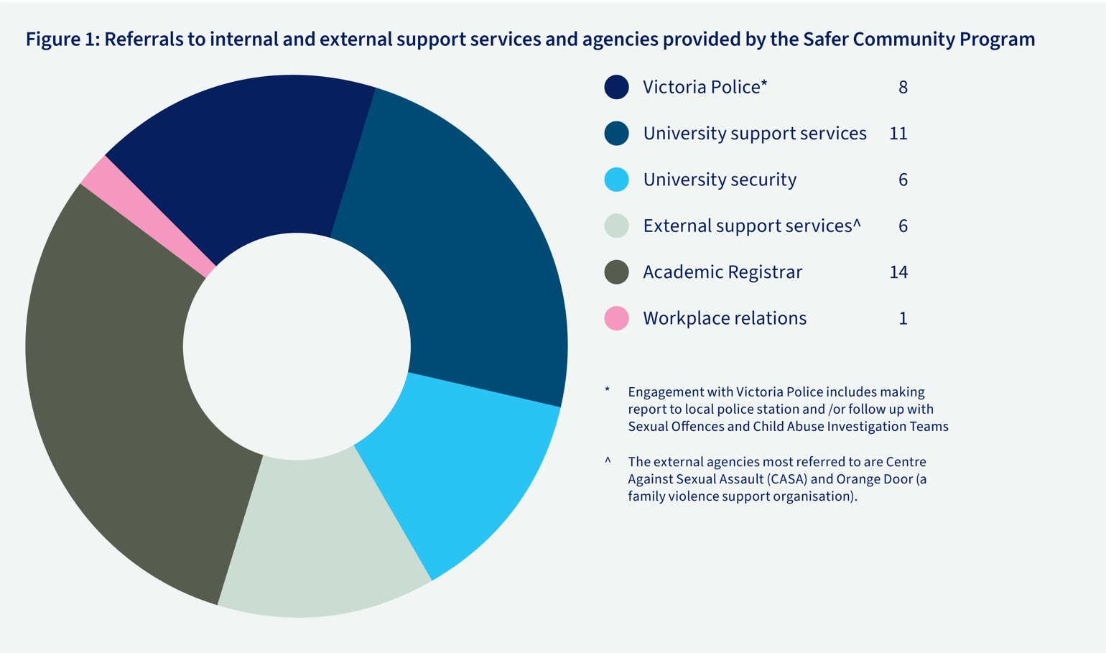

A fair complaints process employing trauma-informed practices
The University encourages students and staff with experiences of sexual misconduct to raise their concerns with the Safer Community Program (for students and staff) or Human Resources (staff only).
If a formal complaint is then made about a staff member, it is reviewed by the Workplace Integrity team, while complaints about students are managed by the Office of the Academic Registrar.
A trauma-informed approach is applied in the management of complaints. For complainants, it includes:
- Having their complaints acknowledged and responded to in a timely manner;
- Being provided with a clear explanation of the next steps and potential outcomes of the complaints process;
- Being given opportunities to communicate their own expectations of the complaints process and outcomes, and to have these considered in the course of formal decision-making processes;
- Being promptly connected with internal and external support services; and
- Having choices about the frequency and type of communication with them from staff managing those complaints.

Complaints against students in 2024
There were 23 complaints of alleged sexual misconduct against students in 2024, down from 25 in 2023, representing an 8% decrease.
Of the 23 complaints made, 20 were within the University’s remit to investigate (Figure 1). This means that they had taken place: on University premises (including in residential colleges and halls that are owned by the University and affiliated colleges and sporting clubs); while using University facilities and services; and/or while engaging in University activities. For those that were outside of the University’s remit to investigate, complainants were connected to support services and/or external reporting options as needed.
Complaints were received by the Office of the Academic Registrar via a range of channels, including the Complaints and Grievances web portal, the Safer Community Program staff, the Speak Safely portal, University security, faculty or other University staff, and external organisations.
In relation to the gender of complainants and respondents, the profile of complaints received in 2024 was as follows:
- 87% complaints came from women (20); 4% were from non-binary students (1); and 9% were complaints where gender was undisclosed, as the matters were raised by departments of the University rather than by students involved. (2)
- 91% of total respondents were men (21) and 9% of respondents were women (2)

Figure 2: Investigation status of complaints against students
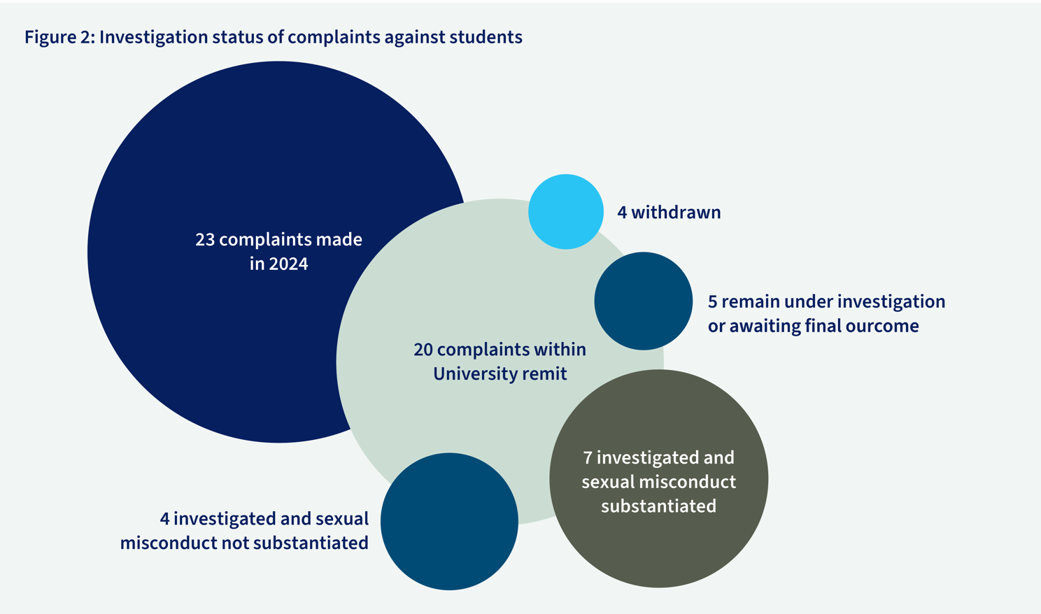
Text version: Investigation status of complaints against students
The graph above shows a breakdown of total student complaints in 2024
- 23 total complaints made
- 20 complaints were within the University remit
  - 4 complaints were withdrawn
  - 5 complaints remain under investigation or awaiting final outcome
  - 7 complaints were investigated and had sexual misconduct substantiated
  - 4 complains were investigated and had sexual misconduct not substantiated

Our student disciplinary process explained
Complaints of student sexual misconduct are addressed according to the Sexual Misconduct Prevention and Response Policy, the Vice-Chancellor Regulation, and the Student Conduct Policy.
Complaints are received by the Academic Registrar, who will promptly contact the complainant to ensure appropriate support is in place for the student. Upon receipt of the details of the complaint, the Academic Registrar will conduct a preliminary assessment and, if necessary, engage a specialist investigator to further examine the allegation (section 5.5 of the Student Conduct Policy details factors considered in this decision). The investigator will report findings of fact to the Academic Registrar, to determine whether the matter should proceed to a student disciplinary committee. Should the matter proceed to a student disciplinary committee, the investigation report will be provided to both the respondent and the committee members. Both the complainant and respondent may submit written or verbal statements and nominate witnesses.
The student disciplinary committee will review the allegations, investigative findings, and any other relevant information, including the complainant’s wishes. Depending on the severity of the misconduct, disciplinary outcomes may take the form of a reprimand, caution, educational directives, enrolment restrictions, suspension, or expulsion from the University.

Student disciplinary decisions in 2024
Of the seven students found to have engaged in sexual misconduct in 2024, a range of behaviours were reported including sexual comments, inappropriate online comments, unwelcome sexual advances, stalking, inappropriate touching and unwelcome general sexualised behaviour.
The penalties applied for the seven substantiated matters were as follows:
- One student was expelled from the University.
- Three students were suspended with conditions placed on re-enrolment.
- Three students faced combined penalties including exclusion from specific locations, no contact directives, mandated training and reflective discussion with CAPS, and targeted education.
In two of the unsubstantiated cases, whilst there was no finding of sexual misconduct, an educative response was recommended by the student disciplinary committee to strengthen the respondents’ awareness and understanding of conduct and behavioural expectations of students at the University of Melbourne.

Complaints against staff in 2024

Numbers of complaints against staff and honorary appointees
In 2024, a total of 21 sexual misconduct complaints were made about staff. This is a substantial increase compared with seven in 2023. Some complaints were brought by more than one complainant and one matter involved more than two respondents. Given that sexual assault and harassment are generally considered to be under-reported, the University views increased reporting as a positive outcome of the University’s efforts to build trust in our systems.
In relation to the gender of complainants and respondents, the profile of complaints received in 2024 was as follows:
- 74% complaints about staff came from women (23); 7% were from men (2); 3% from non-binary people (1) and 16% (5) from anonymous complainants who did not disclose their gender
- 73% of total staff respondents were men (16) and 27% of respondents were women (6)
The Workplace Integrity team reports that the comprehensive program of Respect Education for staff, which the University has delivered since 2021, has been noted by complainants as having helped them to understand that the behaviour they witnessed or experienced was inappropriate and encouraged them to make a report. The team also heard from some complainants that Australian and international media reporting of sexual harassment and abuse has prompted them to reflect on their own experiences and feel empowered to make a complaint.

Figure 3: Complaints made against staff in 2024*
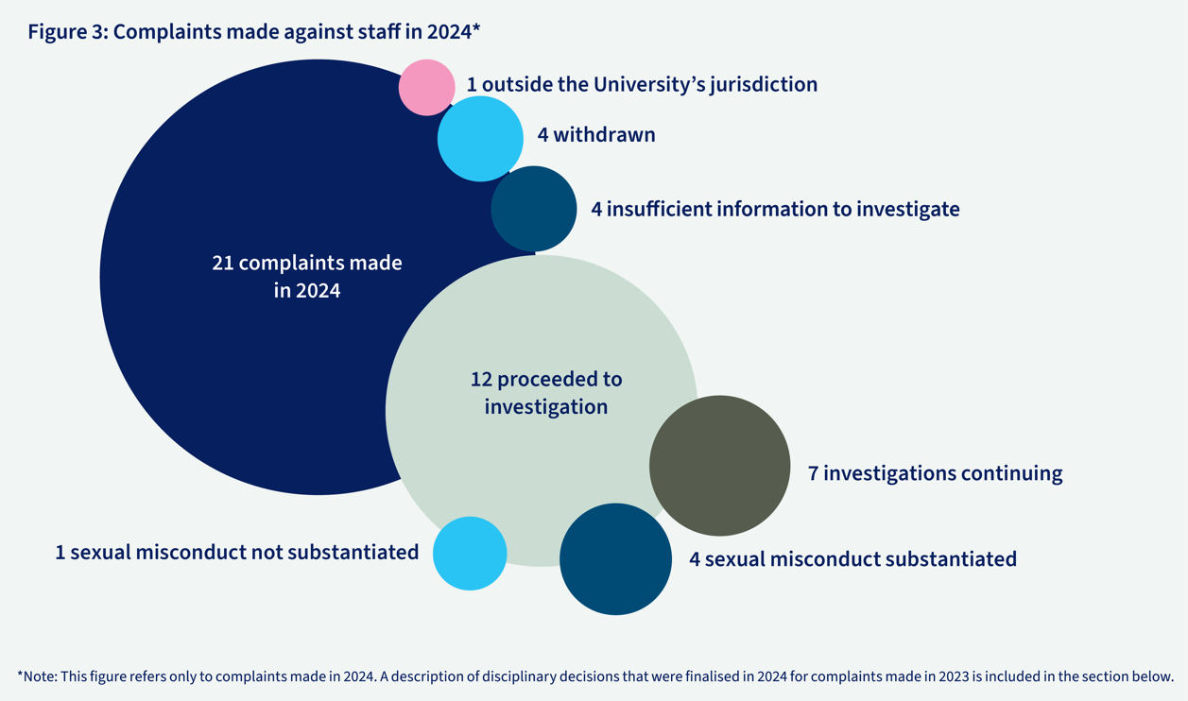

*Note: This figure refers only to complaints made in 2024. A description of disciplinary decisions that were finalised in 2024 for complaints made in 2023 is included in the section below.
Text version: Complaints made against staff in 2024
The graph above shows a breakdown of total complaints made against staff in 2024
- 21 total complaints made against staff
- 1 complaint was outside of the University’s jurisdiction
- 4 complaints were withdrawn
- 4 complaints had insufficient information to investigate
- 12 complaints proceeded to investigation
  - 7 complaints remain under investigation
  - 4 complaints had sexual misconduct substantiated
  - 1 complaint had sexual misconduct not substantiated

Our staff disciplinary process explained
Complaints related to members of staff are handled in line with the Appropriate Workplace Behaviour Policy (MPF1328) and the Sexual Misconduct Prevention and Response Policy (MPF1359). Following a complaint, the Workplace Integrity team conducts a preliminary assessment, taking into account a range of possible outcomes, including no action, mediation, informal management, workplace inquiry or investigation.
Where a case is referred to an independent investigator and sexual misconduct is substantiated, employees face disciplinary action as determined by law and the relevant policies of the University. Honorary staff members can have their honorary appointment rescinded. The Provost (for academic employees) and the Chief Operating Officer (for professional employees) are the decision-makers in these cases.
Where allegations of sexual misconduct are investigated and not substantiated and the respondent continues their employment with the University, ongoing support is offered to the complainant which may include counselling and regular check-ins with senior HR staff. As set out in the Sexual Misconduct Prevention and Response Policy, the University does not ask or require victim-survivors to sign any form of Non-Disclosure Agreement.

Staff disciplinary decisions in 2024
A total of five people were dismissed from the University in 2024 upon a finding of sexual misconduct. Three of these disciplinary decisions related to misconduct that was investigated in 2023, and the employment of all of those respondents was terminated in 2024. (Note: these matters are not included in Figure 3 for reasons of chronology.) Two of these decisions related to complaints substantiated in 2024, which also resulted in termination of employment.

Disciplinary outcomes are pending for the remaining two complaints that were substantiated in 2024.
Correction for noting: The 2023 Sexual Misconduct Annual Report listed six sexual misconduct complaints made against staff. The University neglected to include a seventh complaint. The respondent had resigned in 2022, prior to a disciplinary outcome being finalised in 2023. We apologise for this error and commit to providing as much specificity as possible when reporting on sexual misconduct disciplinary outcomes.

Legal proceedings relating to dismissals
The University is committed to defending decisions to dismiss an employee for sexual misconduct in circumstances where the individual contests the dismissal through the Fair Work Commission or the courts.
In 2024, the University defended a case in the Fair Work Commission regarding the dismissal of an academic who had been found to have sexually harassed an employee. The Commission determined that sexual harassment and, consequently, serious misconduct had occurred, but deemed the dismissal unlawful and ordered reinstatement. At the time of drafting this report, the University had successfully sought a stay on the reinstatement and had lodged an application to appeal the decision to the Full-Bench of the Commission.

‘Speak Safely’ Portal
In 2022, the University established the ‘Speak Safely’ portal, an online platform where victim-survivors can access support, document experiences, or request information or action with trained staff, via an online chat function. One key feature of Speak Safely is the "Diary Note" option, allowing individuals who aren't ready to file a formal complaint to privately record details of an incident, which they may choose to report at a later time.
The portal also offers users the choice to remain anonymous, which may be a critical factor for those concerned about possible negative consequences of their disclosure or complaint. Anonymous reports can limit the University’s ability to respond to a report with specific actions, but the University endeavours to provide a response to all complainants.
In 2024, 15 people used the Speak Safely online portal to tell the University about sexual assault or sexual harassment. Nine reports related to sexual assault and six to sexual harassment. The reports were responded to by the most relevant University department – either the Safer Community Program, the Academic Registrar or Workplace Integrity.

Work completed in 2024
A range of key projects were delivered in 2024 in the final year of implementation of the University’s first Respect Action Plan for the period 2023-2024.

Sector collaboration in 2024
On a national level, the University is a member of the Group of Eight (Go8), attending regular meetings and conferences, including the Go8 Roundtable on Sexual Assault and Sexual Harassment at Monash University in December 2024. The University also participated in Universities Australia consultations in 2024. The University made submissions to the Federal Government in response to consultation on National Higher Education Code to Prevent and Respond to Gender-based Violence, and the National Student Ombudsman.
The University engages with other higher education institutions in Victoria through the Victorian Tertiary Primary Prevention Network (TPPN) to address the prevention of sexual harm, with specific collaboration on Respect at Uni Week.
The University has partnered with Our Watch, especially in relation to its whole-of-university approach to the primary prevention of gender-based violence. Our Respect Initiatives team has met regularly with the Our Watch Universities Lead to gather feedback on our primary prevention efforts.
Both the Safer Community Program and Counselling and Psychological Services (CAPS) work closely with CASA House, the Centre Against Sexual Assault, which offers counselling and advocacy services to victim-survivors of sexual assault, regardless of gender. CASA House has provided guidance in developing training materials for the University. Additionally, the Safer Community Program maintains a collaborative relationship with Victoria Police, regularly consulting with the Sexual Offences and Child Abuse Investigation Teams.

Governance
The Respect Committee oversees the strategic direction of the Respect Action Plan and the execution of the Sexual Misconduct Prevention and Response Policy, with the sponsorship and oversight of the Provost. The Committee’s efforts are guided by the Respect at Melbourne Reference Group, a consultative body made up of staff from faculties, student service providers, student organisations, experts, and affiliated colleges.
The Respect Committee met six times in 2024. The Committee is chaired by the Deputy Vice-Chancellor (People and Community) with the active participation of the Pro Vice-Chancellor (People and Equity), the President of the University of Melbourne Student Union (UMSU), the President of the Graduate Student Association (GSA), the Executive Director, Students and Scholarly Services and Academic Registrar, the Deputy Academic Registrar (Student Complaints and Grievances) and the Chief People Officer.
The Respect Reference Group met quarterly in 2024, discussing and proposing approaches to priority topics including faculty-level support to victim-survivors, prevention and response to online abuse and support for students on placement. Student representatives from GSA, the Law Students Society, UMSU International, and UMSU provided valuable student perspectives. The group also included academic and professional staff from various areas of the University. The meetings were chaired by the Pro Vice-Chancellor (People and Equity).

Preventing sexual misconduct – awareness raising for students
In March 2024, the University launched two new mandatory Preventing Sexual Misconduct online modules for coursework and graduate research students. The modules were developed specifically for University of Melbourne students, with input from a focus group of students, together with UMSU staff members and representatives, University staff and academics. The two modules were launched in Respect at Uni Week on 18 March 2024. At the end of 2024, over 97% of eligible coursework students had completed the module. The modules address sexual misconduct and its impacts, keeping our community safe, how to get help, and how to make a complaint.
Pre- and post-module surveys accompanied the module, enabling the University to monitor the module’s effectiveness, and to provide an opportunity for student feedback on the module. Overall, data in 2024 showed a strong increase in knowledge and confidence in comparison to pre-module levels. For example, after completing the module, 73% of respondents reported having ‘extensive’ knowledge or feeling ’very’ confident in relation to responding to disclosures and bystander intervention, increasing from 27% prior. Almost half of respondents (46%) had little to no knowledge or confidence on how to report or get support for sexual misconduct before completing the module. After completing the training, under 3% of respondents felt this way.
Students identified, through free-text responses, a range of action that they would take after completing the modules. These included actions such as: noticing instances of sexual misconduct; responding as a bystander to observed behaviour; using security services and apps; reporting incidents; practicing affirmative consent and ethical sex; and responding to disclosures in a trauma-informed way. The University will conduct further qualitative monitoring and evaluation of the modules in 2025.

Preventing sexual misconduct – Respect Education for University staff
The University’s Respect Education training is mandatory for all University of Melbourne staff, including those employed on casual contracts. Non-completion of these courses can lead to employee disciplinary proceedings. The program has been delivered in stages from 2021, with progressively greater reach across the organisation. The training is designed to equip staff with the knowledge and skills needed to prevent, call out and respond to issues of sexual misconduct. Content is tailored for different cohorts reflecting their role within the organisation.
At the end of 2024, 57% of current University employees had completed Respect Education (8,117 of 13,870 employees). In 2025, the University will focus on achieving greater compliance through targeted follow up with staff and their supervisors.

Respect at Uni Week
In March 2024, the University facilitated a range of initiatives and events focusing on the primary prevention of sexual misconduct as part of Respect at Uni Week. Highlights included:
- The launch of Preventing Sexual Misconduct modules
- A special panel event featuring holistic consent education advocate Chanel Contos, University of Melbourne masculinities expert Dr Stephen Burrell, and the University of Melbourne Provost, Professor Nicola Phillips, on the role of universities in preventing sexual harm. The panel was attended by 160 staff and students (in-person and online)
- A range of student-led activities across our campuses, focused on support services available and the importance of consent.

Looking ahead: Developing the Respect Action Plan 2025-26
In December 2025, the University’s second Respect Action Plan was published, setting out the University of Melbourne’s program of work to prevent and respond to sexual misconduct in 2025-26.
The Respect Action Plan 2025-26 builds on the successes of, and learnings from, the University’s first Respect Action Plan implemented in 2023 and 2024. The Plan is informed by recommendations from victim-survivors, University subject matter experts, and student and staff representatives. It also anticipates the National Higher Education Code to Prevent and Respond to Gender-based Violence. New action areas focus on preventing online sexual harassment and abuse; embedding consistent approaches in University-owned colleges, accommodation and MU Sport and increasing men’s engagement with prevention approaches.
It was critical that lived experience consultation informed the development of the new Respect Action Plan. The University commissioned Ms Sharna Bremner, Founder and Director of End Rape on Campus, to consult with students who had experienced sexual misconduct, both those who had reported and those who had chosen not to report. Based on the views of participants, Bremner’s report provided 12 recommendations, to which the University has responded in the development of the Respect Action Plan 2025-26. These recommendations and responses are included in Appendix 2.

Addressing online sexual harassment and abuse
The University recognises that digital spaces are a key site of harassment, abuse, and technology-facilitated sexual violence, and that these harms are disproportionately targeted towards women, LGBTIQA+ people, Indigenous Australians, people of colour, and people living with a disability/disabled people.
A pulse survey circulated by the GSA (2024) indicated that 52 graduate researchers at the University had experienced hate or harassment through the publication or communication of their research; 42% of these cases included an online component. The harassment occurred through a variety of platforms including social media, personal email or phone, messaging apps, university email platforms and university online noticeboard. While these are experiences of harassment more broadly, and not specifically sexual harassment, the survey reinforces the seriousness of the challenge to address online harm in the University community.
In 2025, the University will develop and publish information to raise awareness about online and image-facilitated abuse and support available. Online safety tools for staff and research students will be co-designed and published, drawing on existing examples of social media self-defence and respectful disagreement content.

Consistent approaches in University-owned and affiliated colleges
The University concurs with the priorities set out in the Sexual Misconduct Reporting Lived Experience Review conducted by Sharna Bremner in relation to University-owned colleges. In 2024, a new Sexual Misconduct Prevention and Response Community of Practice for University-owned and affiliated colleges has been established and will meet quarterly in 2025. Priorities include:
- Improving consistency of sexual misconduct policies and processes between colleges, and with the University
- Building University and college staff awareness of complaints process and support services.
- Providing training for college and University staff in supporting people affected by gender-based violence.

Increasing men’s engagement with prevention approaches
The University’s Respect Theory of Change commits to the achievement and maintenance of a University culture that values equal, positive, and safe relationships and challenges harmful gendered attitudes, structures and practices.
The University commits to primary prevention of sexual violence which, as articulated by Our Watch, addresses the underlying drivers of violence: the condoning of violence; men’s control of decision-making over women; rigid gender stereotyping; and harmful and aggressive male peer relations.
In 2025, the University will commence consultation with subject matter experts to develop and deliver approaches to increase men’s engagement and shared responsibility for a safe community at the University.
To strengthen the effectiveness or reach of existing work, the action plan also considers a range of process improvements or refinements relating to prevention messages for different cohorts, education modules and integration of Respect information into existing processes.
Some actions from the 2023-24 Action Plan have been integrated into standard University ways of working, such as regular review of the Sexual Misconduct Prevention and Response Policy, publication of the Sexual Misconduct Annual Report, updates to the Respect website and brochures and ongoing evaluation of the Speak Safely Portal.

Appendix 1: Glossary of terms
Affiliated means
- For a college, affiliated by the University Council in accordance with the University of Melbourne Act 2009, statute and regulations;
- For a student club or society: (i) affiliated by UMSU Incorporated or The University of Melbourne Graduate Student Association; or (ii) affiliated, recognised, or supported (however described) by a faculty, school, or department of the University.
Bystander means someone who witnesses an incident of sexual misconduct or is told about an incident after it occurred.
Complaint means a complaint of sexual misconduct relating to University matters by an individual who wants the University to take specific action in response to the incident.
Complainant means any person who makes a complaint of sexual misconduct to the University.
Disclose / disclosure means an individual telling a University staff member about their experience or witnessing of sexual misconduct. Unlike a complaint, disclosure does not trigger an investigation or action unless the University has a duty of care to do so. It may also be the first step prior to a complaint being made.
Gender-based violence means violence directed against a person because of that person's gender or violence that disproportionately affects persons of a particular gender. It includes acts that inflict physical, mental or sexual harm or suffering, threats of such acts, coercion and other deprivations of liberty.
Non-Disclosure Agreement means any agreement, or any clause in any agreement, that prohibits a victim-survivor from being able to speak freely about their lived experience of the matters disclosed or complained of.
Procedural Fairness means that, at a minimum:
- The parties are given notice of the complaint or allegations against them, and the process by which it is proposed that the matter will be resolved.
- The parties are given the opportunity to be heard and respond to the complaint or allegations.
- The decision-maker acts impartially.

Respondent means a person about whom a complaint is made.
Trauma-informed means an approach that maximises the safety, wellbeing and support provided to individuals who make disclosures or complaints. This aims to uphold their agency, safety, dignity and wellbeing, and recognise that an unsafe response can escalate and compound trauma.
University means the University of Melbourne, and in this report references to ‘the University’ also includes its controlled entities, and in respect of student sexual misconduct, affiliated residential colleges, clubs and societies.
Sexual misconduct is the term the University of Melbourne uses to cover the full range of inappropriate sexual behaviour that is within the University’s remit to investigate and penalise, as outlined in the Sexual Misconduct Prevention and Response Policy. Sexual misconduct includes sexual harassment and sexual assault, whether it happens face-to-face or online (e.g. via email or social media).

Appendix 2: Summary of recommendations from consultation with students with lived experience of sexual misconduct at the University, and responses by the University.
Recommendation 1: Increasing awareness of the complaints process
Response: The University has committed to reviewing existing resources and those provided by others in the sector to ensure best practice, in line with this recommendation. Monitoring of the Preventing Sexual Misconduct module for students has indicated a positive shift in student awareness of complaints processes and available support. A joint University and UMSU bystander action campaign also commenced in 2024, with further actions included in the Respect Action Plan 2025-26.
Recommendation 2: Addressing the needs of international students
Response: Developing resources specifically for international students, and in plain English, has been prioritised in Respect Action Plan 2025-26.
Recommendation 3: Provision of information about the complaints process
Response: The Respect website will be reviewed and improved, as set out in the Respect Action Plan, and this recommendation will be referred to during the review.
Recommendation 4: Physical space to enable in-person reporting
Response: The University has committed to providing a welcoming space for the Safer Community Program, as reflected in the Action Plan.
Recommendation 5: Policy reviews to ensure that they will align with the requirements of the National Higher Education Code to Prevent and Respond to Gender-based Violence.
Response: A review of the Sexual Misconduct Prevention and Response Policy together with a range of relevant University policies will be conducted in 2025, taking the National Code into account when it is established.
Recommendation 6: Provision of information for practical steps immediately following a sexual assault, including external health services, options for medical treatment, and crisis care.
Response: The Respect website review in 2025 will refer to this recommendation, ensuring that students are provided with this practical information.
Recommendation 7: Reviews of University support services to ensure practices are trauma-informed, student-centred and fit for purpose, staff are trained to support people impacted by GBV, D&I and disability.
Response: Students and Scholarly Services have undertaken a review of support services during 2023 and 2024. This has led to the University committing to a program of improvements. Additionally, training for support service staff is included within the Respect Action Plan 2025-26.
Recommendation 8: Engagement with clubs and societies to ensure reporting of incidents to the University, training for leaders and risk mitigation measures
Response: This recommendation has been directly adopted via targeted activities for clubs and societies included within the Respect Action Plan 2025-26.
Recommendation 9: Student accommodation - local policies & processes align with the University’s; and staff provided with training.
Response: This recommendation has been directly adopted via targeted activities for colleges and accommodation included within the Respect Action Plan 2025-26.
Recommendation 10: Training for teaching staff covering the University’s complaints and support policies and processes
Response: A review of employee induction is included in the Respect Action Plan 2025-26, in line with this recommendation. Separate training sessions for teaching staff are also under consideration.
Recommendation 11: Training for student support staff in supporting people impacted by gender-based violence and in diversity, inclusion, and disability awareness.
Response: The University’s Disability Inclusion, LGBTIQA+, and Anti-Racism action plans include training for frontline staff. A Disability Inclusion subject matter expert has now been appointed to the Respect Reference Group.
Recommendation 12: Complaints updates and outcomes to ensure that the complainant and respondent are provided with regular updates on the progress of the complaint and findings
Response: Improvements to communications with both complainants and respondents have been brought into effect in line with this recommendation.

Our Watch. (2021). Change the story: A shared framework for the primary prevention of violence against women and their children in Australia (2nd ed.). Our Watch.

