Level 6, 757 Swanston St, Parkville VIC 3010
Google Maps Link
Maps.unimelb Link
Parking and Transport
Campus information Link
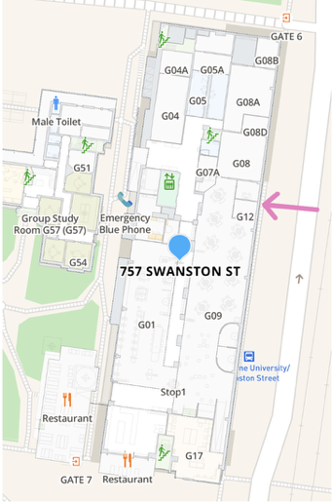
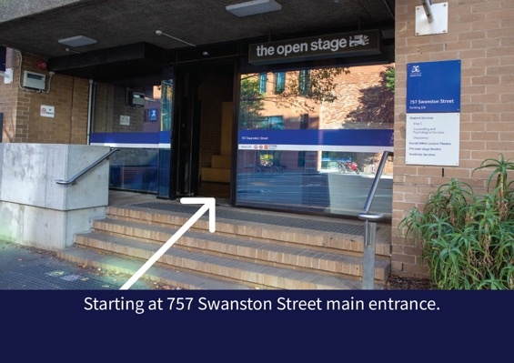
Step 1: Starting at 757 Swanston Street main entrance.
Enter through “the open stage door”
Building is opposite to Melbourne Connect or the Unimelb Tram Stop
Building has Scholar & Co Cafe in it

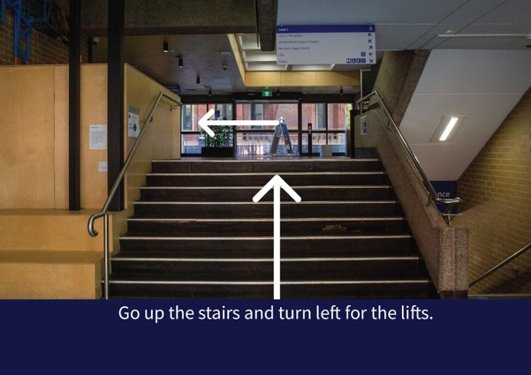Step 2: Go up the stairs and turn left for the lifts.

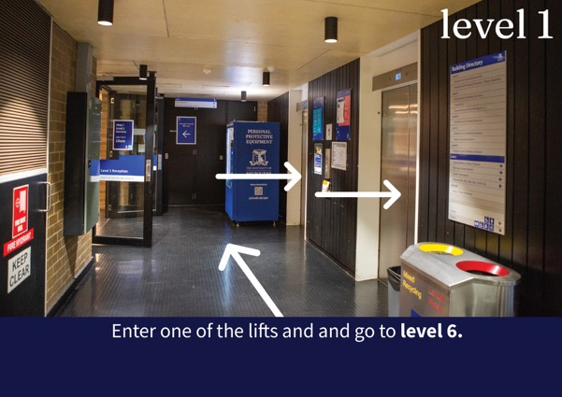Step 3: Enter one of the lifts and and go to level 6.

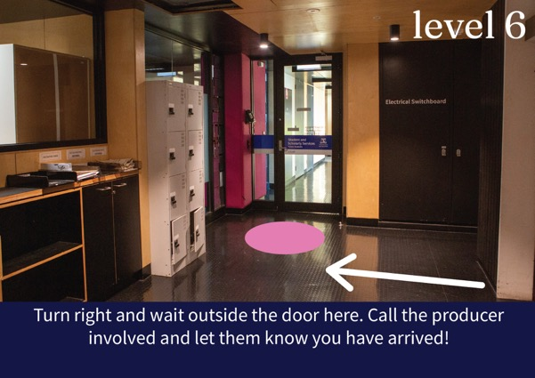Step 4: Turn right and wait outside the door here. Call the producer involved and let them know you have arrived!

