Internet Browser Patch-a-thon

The following instructions explain how to check if your browser is up to date. When you don’t open your browser for a while, updates may be pending, and these can lead to vulnerabilities. Check your browsers are up-to-date and help keep your University safe.

Chrome
https://support.google.com/chrome/answer/95414?hl=en&co=GENIE.Platform%3DDesktop&oco=1
Normally updates happen in the background when you close and reopen your computer's browser. But if you haven't closed your browser in a while, you might find a pending update:
- On your computer, open Chrome.
- At the top right, select More (three dots in a line).
- If an update is pending, you'll find:
  - "Relaunch to update"
  - "Finish update"
  - "New Chrome available"
To update Google Chrome:
- On your computer, open Chrome.
- At the top right, click More .
- Click Help About Google Chrome.
- Click Update Google Chrome.
  - Important: If you can't find this button, you're on the latest version.
- Click Relaunch.
The browser saves your opened tabs and windows and reopens them automatically when it restarts. Your Incognito windows won't reopen when Chrome restarts. If you'd prefer not to restart right away, click Not now. The next time you restart your browser, the update will be applied.

Edge
https://support.microsoft.com/en-au/topic/microsoft-edge-update-settings-af8aaca2-1b69-4870-94fe-18822dbb7ef1
By default, Microsoft Edge automatically updates when you restart your browser. However, there are two situations where you may need to manually download an update:

- Metered connections, whether cellular, wi-fi or Ethernet, have data limits associated with them. Because an update may involve a large data transfer, we let you decide when to update. For more information about metered settings in Windows 10, go to Metered connections in Windows 10.
- If you recently purchased your device in China and it has cellular capabilities, your updates may be turned off by default.
If either of the categories above apply to you, use the following procedures to update your browser:

Update once
In the browser, go to Settings and more > Help and feedback > About Microsoft Edge (edge://settings/help).
- If the About page shows Microsoft Edge is up to date, you don't need to do anything.
- If the About page shows An update is available. Select Download and install to proceed. Network charges may apply., select Download and install. Microsoft Edge will download the update an apply it the next time you restart Microsoft Edge. Note that if you're on cellular network, downloading the update may incur charges.
- If the About page shows To finish updating, restart Microsoft Edge., select Restart. The update is already downloaded and all you need to do is restart the browser for it to be applied.
Always stay up to date
We recommend that you always stay up to date to keep your browser secure and working properly.
In the browser, go to Settings and more > About Microsoft Edge (edge://settings/help). Depending on where you purchased your device, you may see one or both of following toggles:
- Download and install updates automatically
- Download updates over metered connections.
Turn on any available toggles to always allow automatic downloads of updates. Note that turning on Download updates over metered connections might incur charges if you're connected to a cellular network.

Safari
https://support.apple.com/en-us/108382
The most up-to-date version of Safari is included with the latest version of the operating system for your Apple device.
Use Software Update
- Open Software Update:
  - From the Apple menu  in the corner of your screen, choose System Settings. Click General in the sidebar of the window that opens, then click Software Update on the right.
  - If you don't have System Settings in the Apple menu , choose System Preferences instead. Then click Software Update in the window that opens.
  - Don't see Software Update settings?
- When you open Software Update, it automatically begins checking for new software.
  - If new software is available for your Mac, click the button to Update or Upgrade. What's the difference between an update and upgrade?
  - If new software is not available for your Mac, Software Update says that your Mac is up to date. Software Update shows only software that is compatible with your Mac model. For example, if your Mac is not compatible with a later version of macOS or Safari, Software Update does not offer it to you. Which Mac models are compatible?
- Before installation begins, you will be asked to enter your administrator password. It's the password you use to log in to your Mac. Forgot your password?
- During installation, your Mac might restart and show a progress bar or blank screen several times. If installation is not successful, learn what to do.

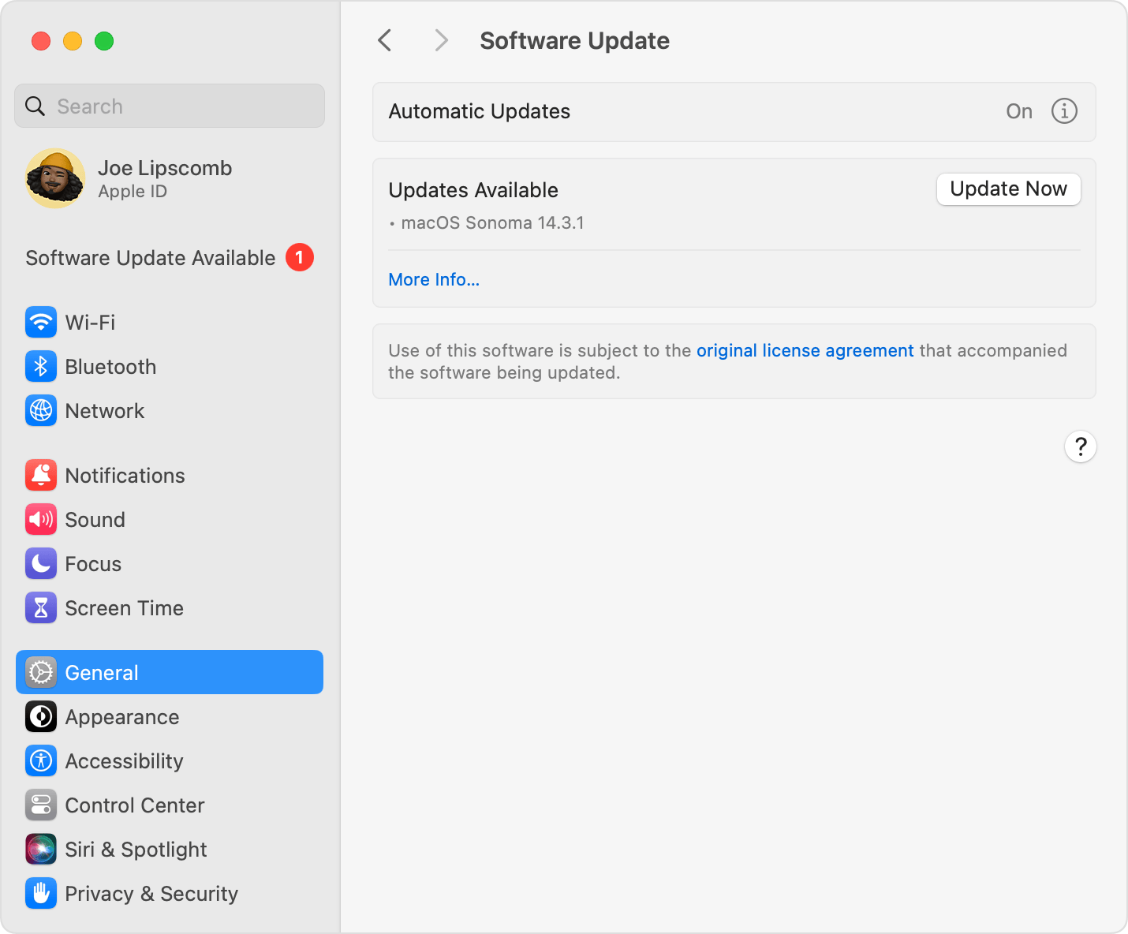

Firefox
https://support.mozilla.org/en-US/kb/update-firefox-latest-release
Firefox updates automatically by default but you can always check for updates at any time.
Update Firefox
- Click the menu button at the right side of the Firefox toolbar, go to Help, and select About Firefox. The About Mozilla Firefox window will open.
- Firefox will check for updates automatically. If an update is available, it will be downloaded.
- When the download is complete, click Restart to update Firefox.
Configure how Firefox installs updates
- Click the menu button and select Settings.
- In the General panel, go to the Firefox Updates section.
