Students' instructions

Week 11 Tutorial Activity: GenAI as a Debater
Topic: Native Title and Development for First Nations Australians
Format: On-campus, interactive roleplay debate
Date: 14–15 October 2025
Duration: 15 minutes prep I 30 minutes activity time

Purpose of This Tutorial
This tutorial helps you learn how to use Generative AI (GenAI) responsibly to support your thinking and writing for Assignment 3. You’ll engage in a live debate simulation with GenAI and explore how native title can be used as a tool for development for First Nations Australians.
You need to include the AI-generated output from this tutorial as an Annexure in Assignment 3.
Please note: Using Copilot is optional for Assignment 3. You can write responses to the following question and add use it in your report.
- What does “development” mean for First Nations Australians?
- What are the challenges and opportunities of using native title for development?
- Choose a challenge from the 2003 Native title Report that remains unresolved. Propose your own solution.

Learning Objectives
By the end of this activity, you will be able to:
- Explain who First Nations Australians are and what native title means.
- Distinguish native title from freehold ownership.
- Define “development” using capability theory.
- Identify opportunities and challenges in using native title for development.
- Propose and defend reforms that address these challenges.

Your Role in the Debate
You’ll participate in a roleplay debate facilitated by GenAI, who will act as Simon, the Social Justice Commissioner. You will take on one of the following roles:
- Policy Analyst
- Indigenous Advocate
- Development Consultant
Together, you’ll explore:
- How native title supports development.
- What reforms could improve its effectiveness.

Preparation Checklist (15 mins)
Before starting the activity
- Read Chapter 1 of the Native Title Report 2003.
- Review capability theory and its relevance to development.
- Reflect on how land rights relate to economic and social empowerment.

Using Copilot via Microsoft Outlook
To access Copilot through Microsoft Office 365:
- Install Office 365: Download it from https://studentit.unimelb.edu.au/software/microsoft-365
- Sign in: Open any Office app (e.g., Outlook) and log in with your Unimelb student ID.
- Open Copilot: In Outlook, click on Copilot in the left-hand ribbon.
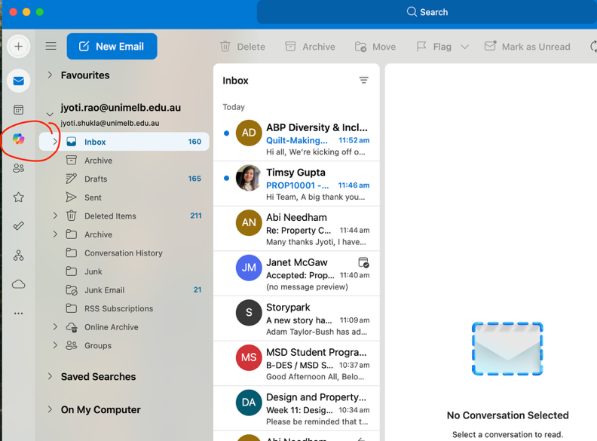

How to Start the Debate with Copilot
- Start a new chat in Copilot.
- Paste the debate prompt (provided below in red ink) into the chat window.
- Engage in the debate by responding to questions and contributing your role’s perspective.
- Save your chat by generating a shareable link.

Saving and Submitting Your Chat
After the debate:
- Click the Share button (top-right corner of the chat).
- Copy the link to your chat thread.
- Paste the link into a Word document.
- Save the document and include it as an Annexure in your Assignment 3 submission.
If you use multiple chat threads, include links to all of them.

