Celebrating Neurodiversity
Research Symposium
Thursday 14th November
9:30am — 2:45pm
Level 5, Kwong Lee Dow Building
Faculty of Education
Join us for the first-ever Celebrating Neurodiversity Research Symposium at the University of Melbourne! This interactive event is an exciting opportunity to learn about the innovative research happening at our institution, as well as a platform to hear from neurodivergent researchers sharing their work in a range of areas.
This symposium will be split into two streams:
1. Neurodiversity-affirming research stream sharing research from across all faculties and schools that seeks to shift understandings of neurodivergences from deficits to differences.
2. Neurodivergent researchers sharing their work in any field, making visible the wonderful contribution University of Melbourne neurodivergent academics make to their fields of inquiry.
As a celebration of neurodiversity, this event will bring together our community to connect with each other and is designed to allow people to access the day in ways that work best for them.
Open to all University of Melbourne students and staff members.
View our Symposium schedule, speaker profiles and fun activities for the day on our website.
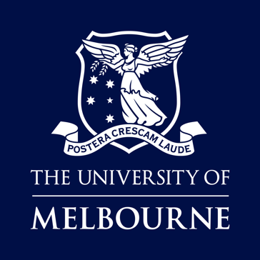

Find out more and register:


