G10, Ground Floor, Elisabeth Murdoch Building, Spencer Rd, Parkville 3010
Google Maps Link
Maps.unimelb Link
Parking and Transport
Campus information Link
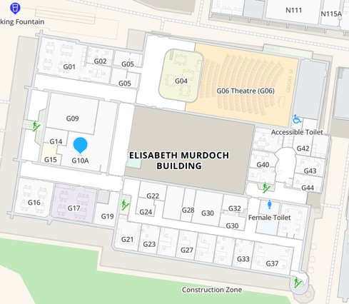

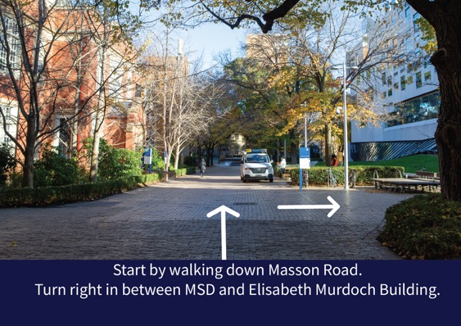
Step 1: Start by walking down Masson Road. Turn right in between MSD and Elisabeth Murdoch Building.

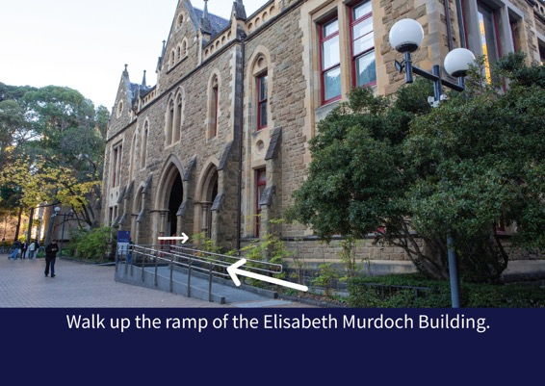
Step 2: Walk up the ramp of the Elisabeth Murdoch Building.

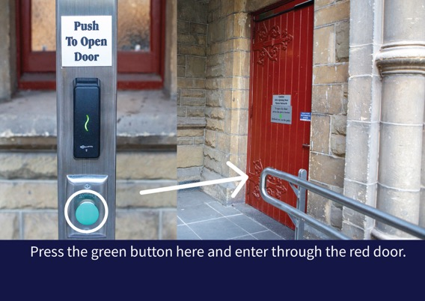
Step 3: Press the green button here and enter through the red door.

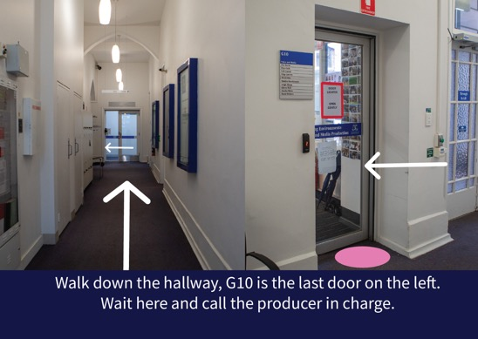
Step 4: Walk down the hallway, G10 is the last door on the left. Wait here and call the producer in charge.

