Heuristics: Redesigning assessment task
(Part of the module: Beyond ChatGPT - Let's Get Practical About Assessment Design.)
Teaching and Learning Innovation, Learning Environments, University of Melbourne.
Version 1.1. Last Updated: 20-07-2026.
Author: Jenny Pesina.

Table of Contents
Re-thinking an assessment task 2
Assessment design heuristics: sets 3
Set 1: Academic Integrity 3
Set 2: Focus on the process 4
Set 3: Social and societal impact 5
Set 4: Context and specificity 6
Set 5: Accessibility and inclusion 7
Set 6: Modelling of GenAI tools in disciplines 8
References 9

Re-thinking an assessment task
This guide focuses on an ideation of one of your current assessment tasks. It can also be applied to design of new assessment tasks.
A series of assessment design heuristics are used to identify whether the task meets your intentions, or whether any changes need to be made to any components of the task (e.g., description, guidelines or rubric):
- Assessment task description
- Guidelines for the students
- Guidelines for the marking team (if applicable)
- Assessment task components (e.g. what are the steps in this assessment
- task?)
- Assessment task weighting (in relation to the overall assessment
- structure)
- Rubric
- Feedback and feed-forward approaches.
TIPS – HOW TO USE
You can choose one or more areas of focus and use the prompts within each heuristic set to guide your thinking.
These heuristic sets are intended to spark ideas rather than provide a checklist. You may choose to focus on one area or combine prompts across several sets. Strong assessment redesign often draws on multiple heuristics to create complementary sources of evidence of student learning.
There is no single "correct" redesign. Use the prompts to explore possibilities, test ideas, and identify changes that best support learning within your own disciplinary context.

Assessment design heuristics: sets

Set 1: Academic Integrity
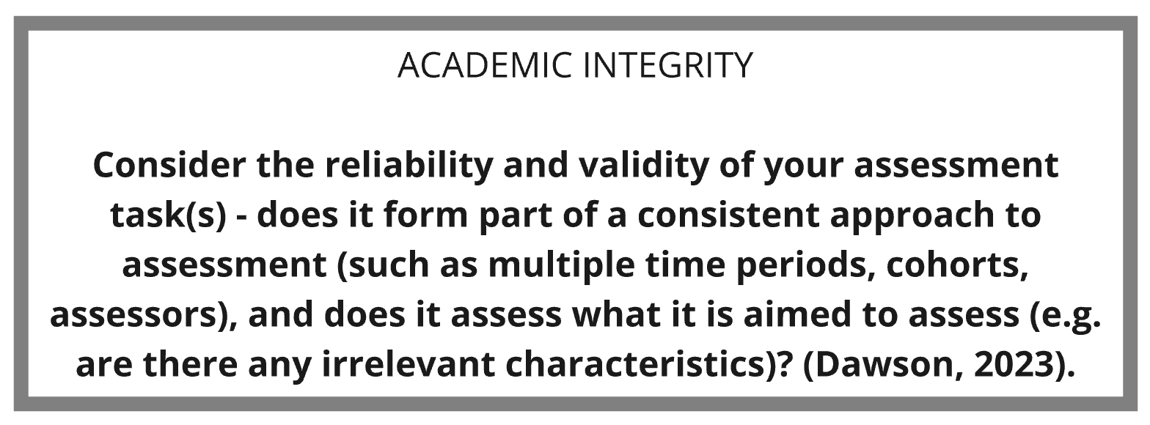

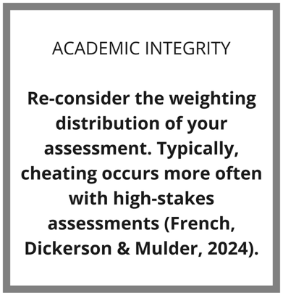
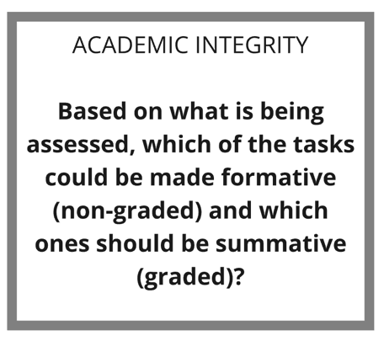

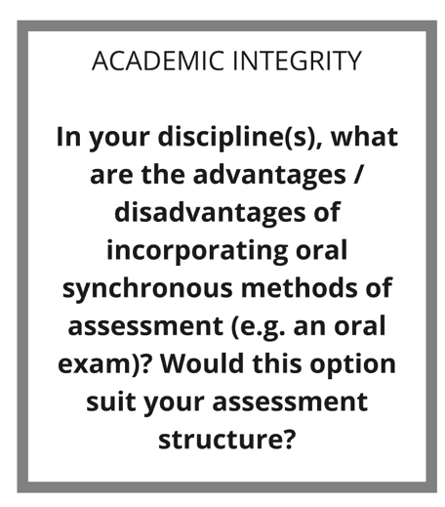
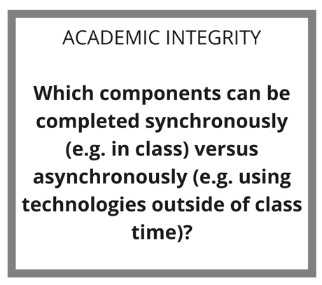

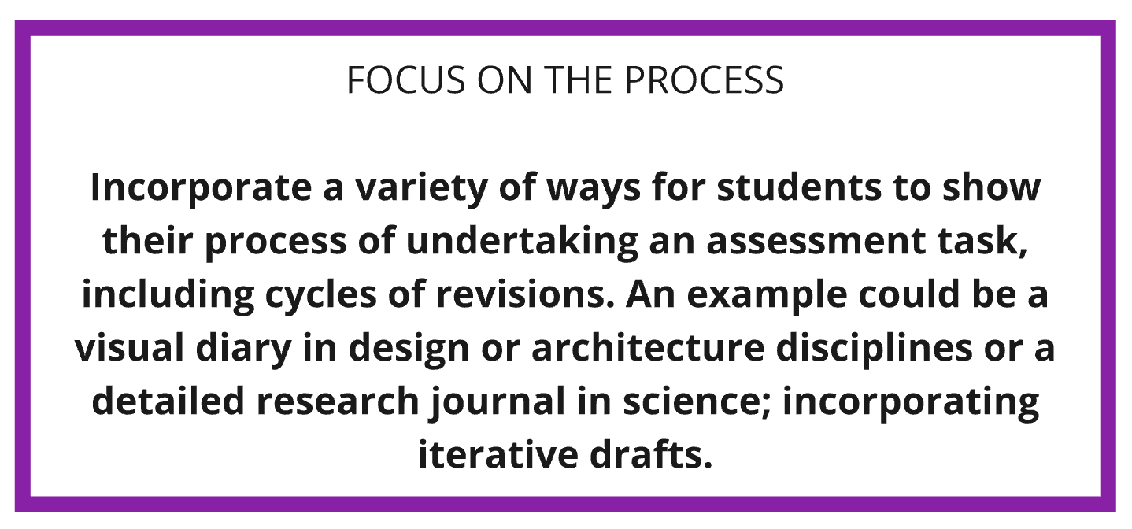
Set 2: Focus on the process

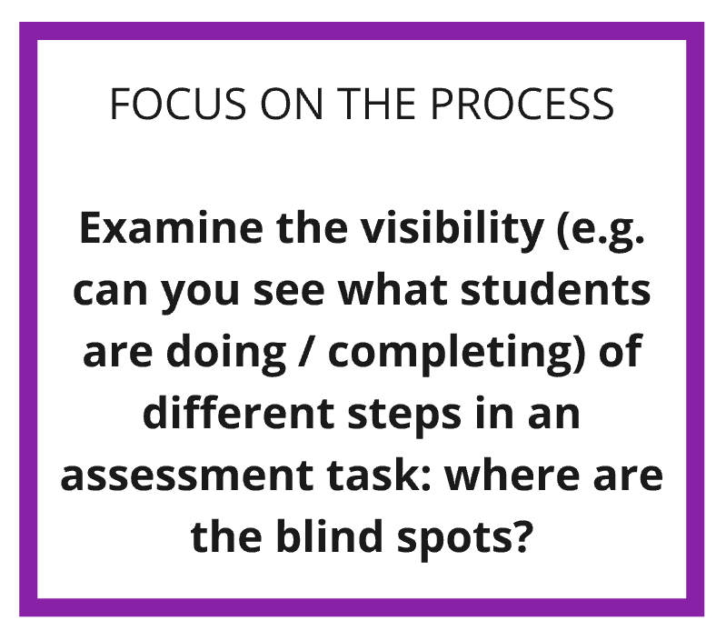
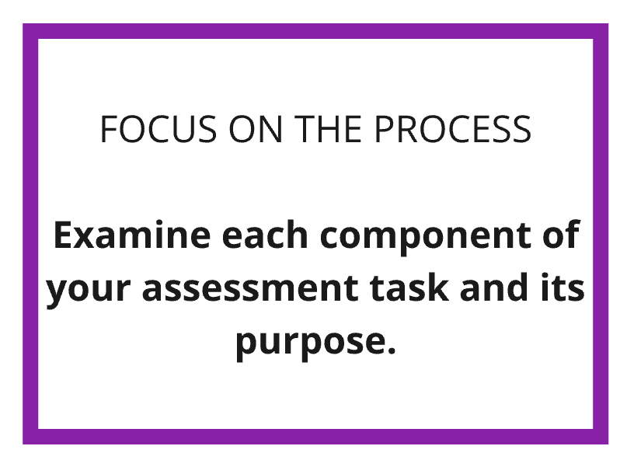
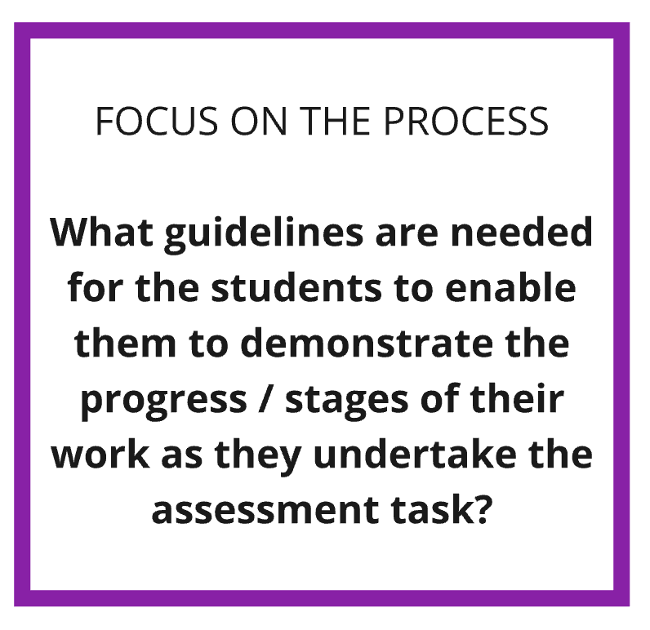
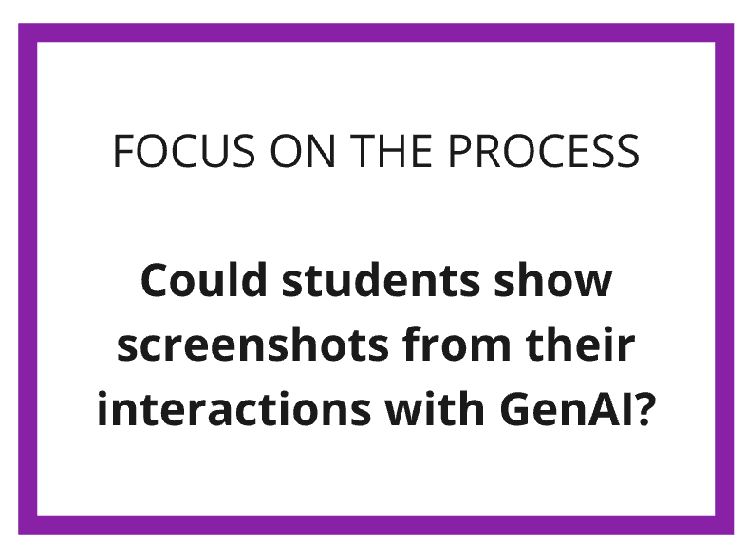

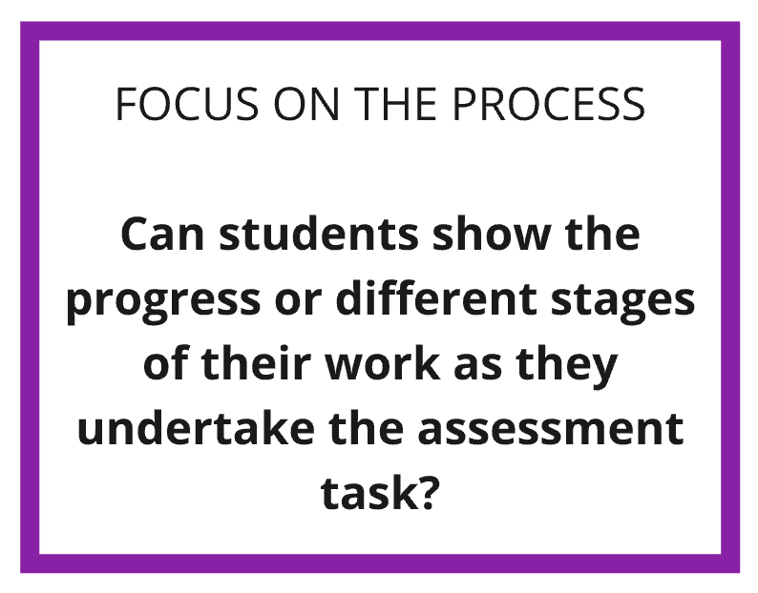

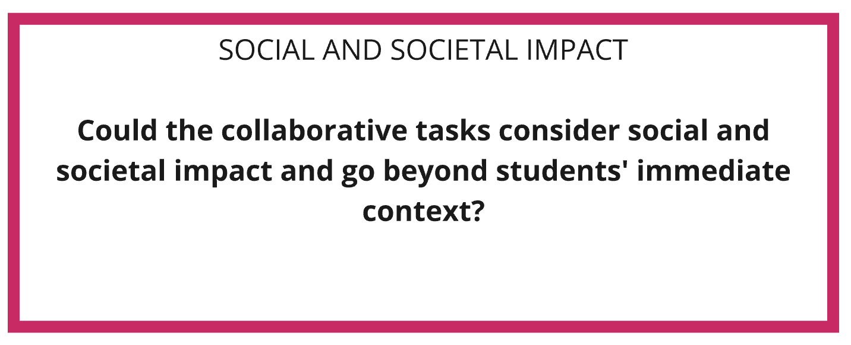
Set 3: Social and societal impact

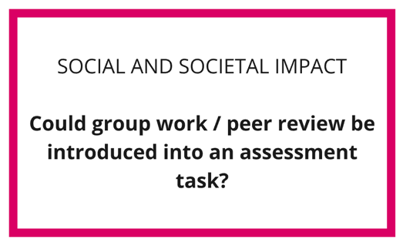
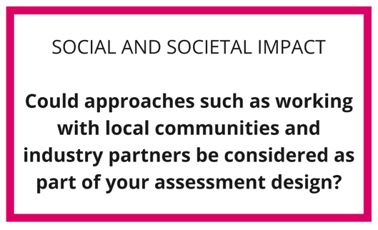

Set 4: Context and specificity
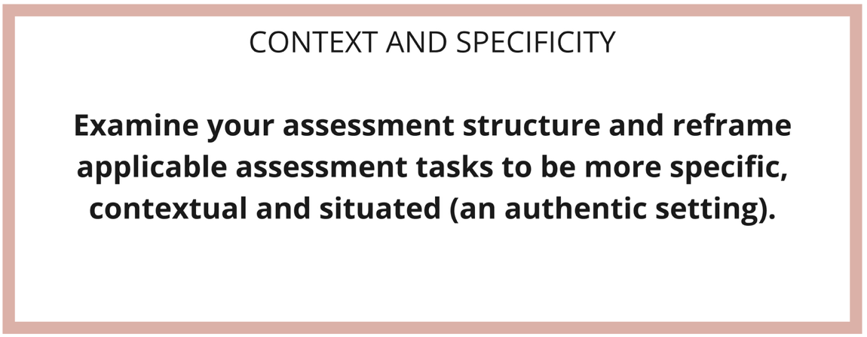

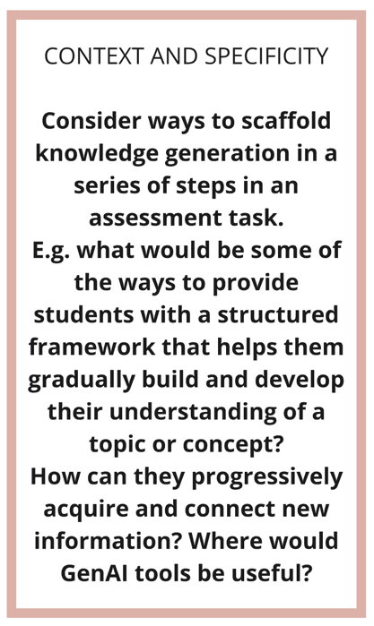
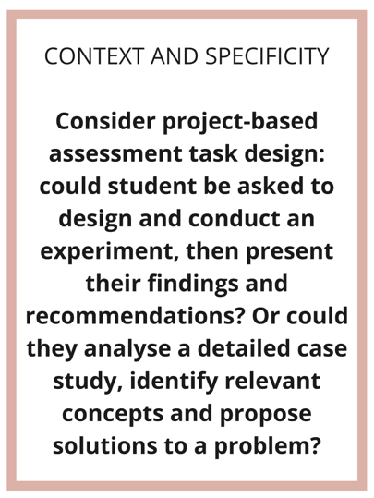

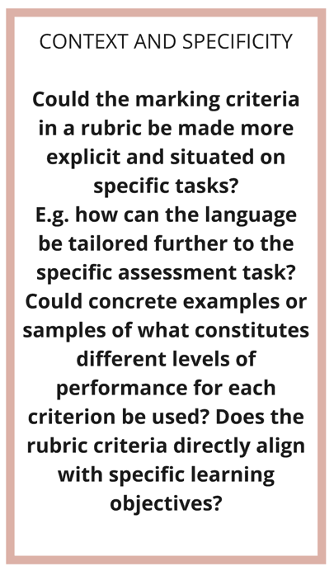

Set 5: Accessibility and inclusion
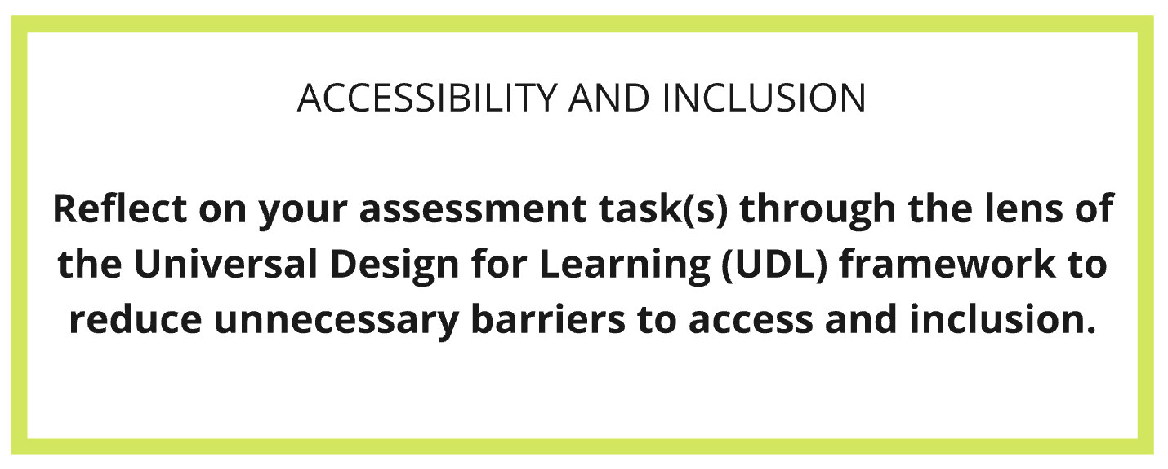

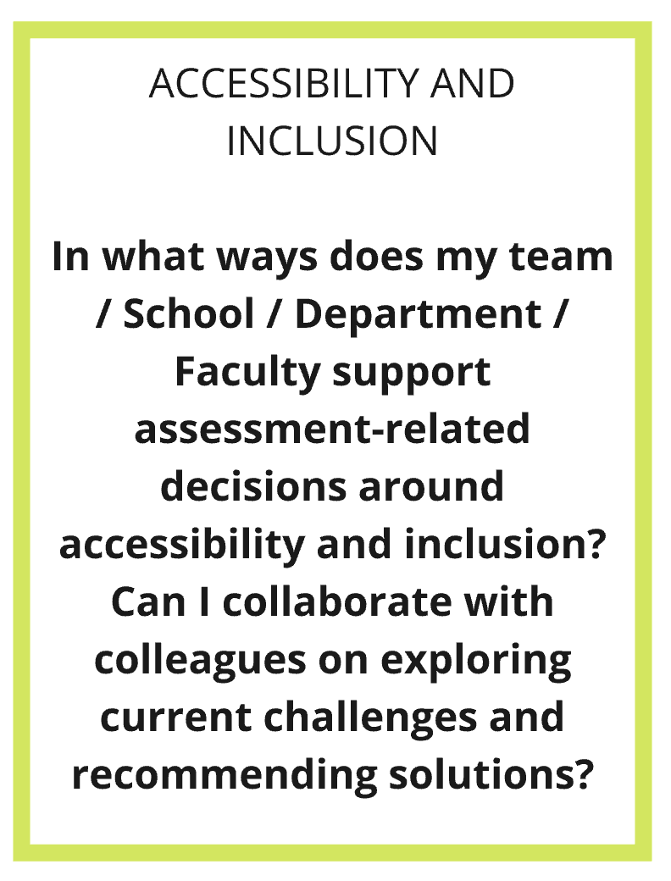
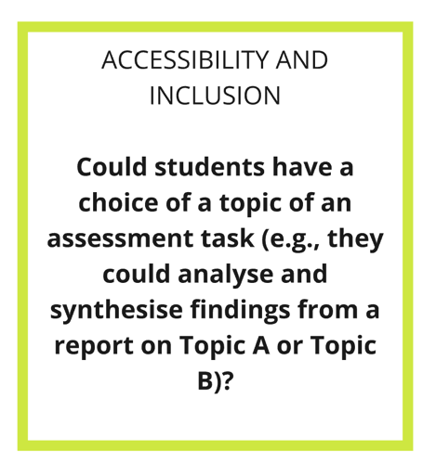
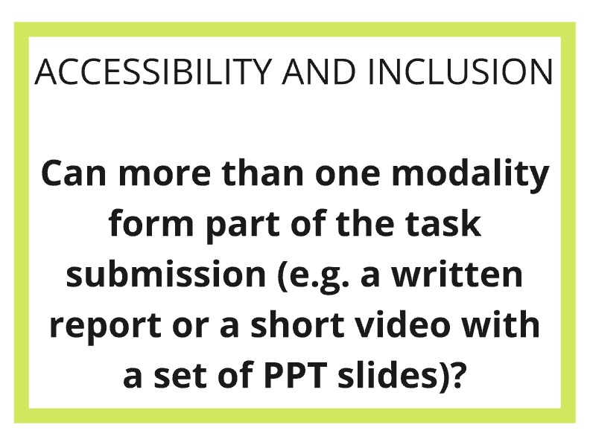

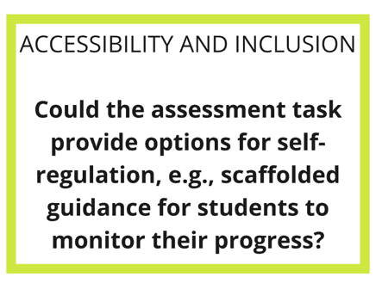

Set 6: Modelling of GenAI tools in disciplines
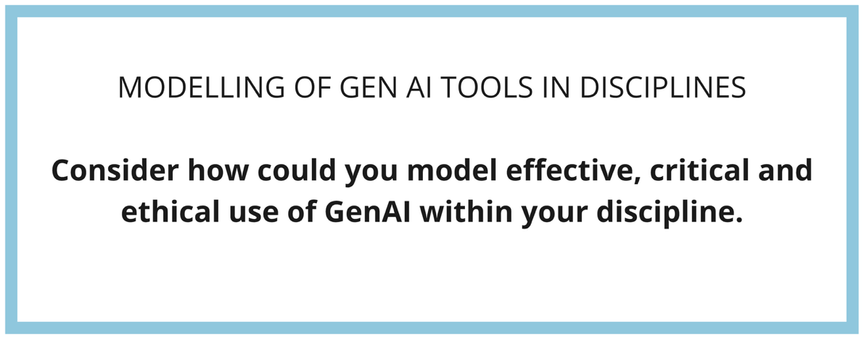

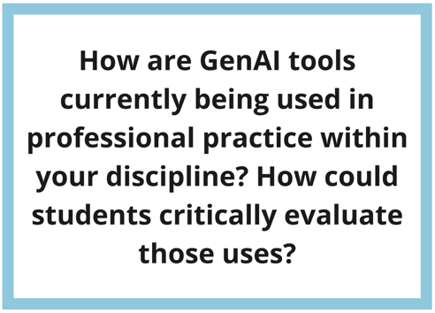
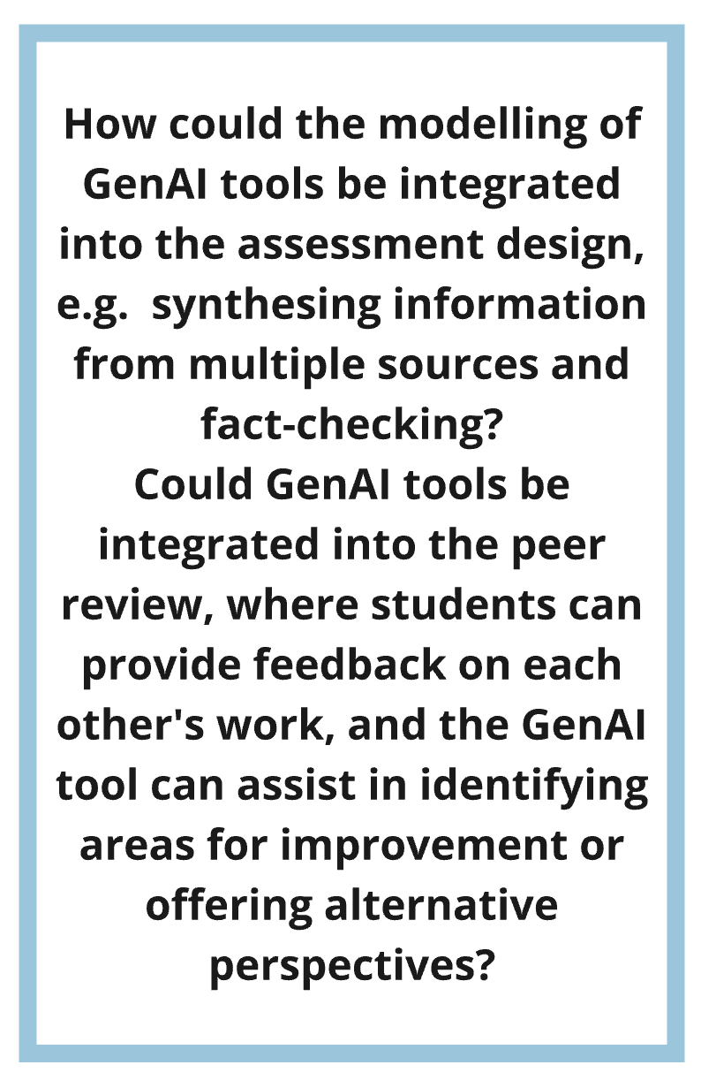
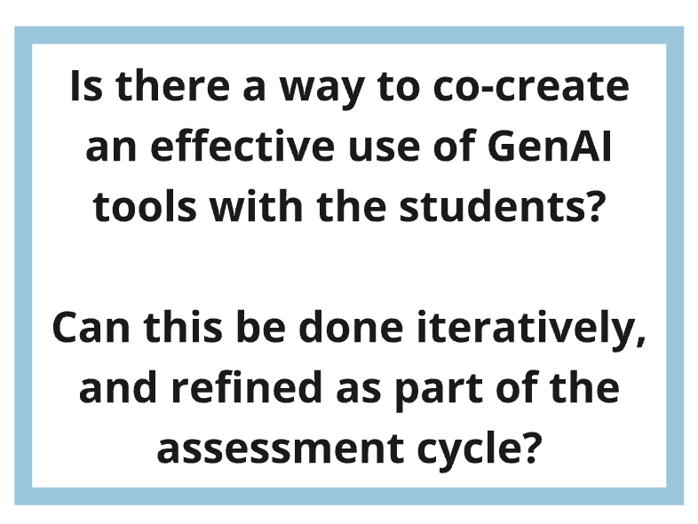

References
Dawson P. (2023, September 9). Heriot-Watt University 'Inspiring Learning' New Year Lecture 2023 by Prof Phil Dawson [Video]. YouTube. https://youtu.be/QHINgkf9KTA?t=1582
French, S., Dickerson, A., & Mulder, R. A. (2024). A review of the benefits and drawbacks of high-stakes final examinations in higher education. Higher Education, 88(3), 893-918.

