Ground Floor, Elisabeth Murdoch Building, Spencer Rd, Parkville 3010
Google Maps Link
Maps.unimelb Link
Parking and Transport
Campus information Link
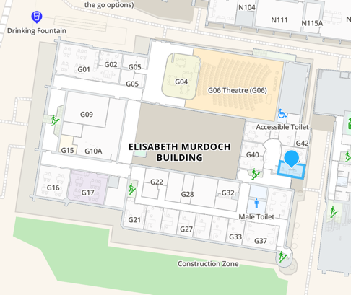

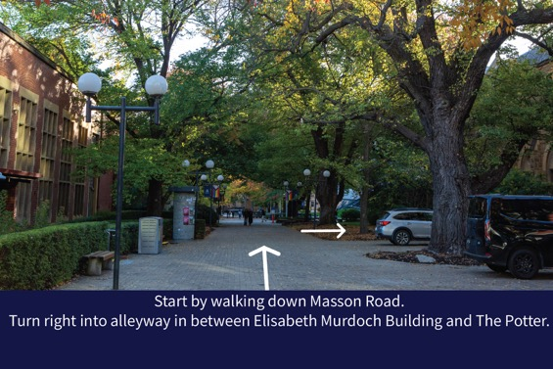
Step 1: Start by walking down Masson Road. Turn right into alleyway in between Elisabeth Murdoch Building and The Potter.

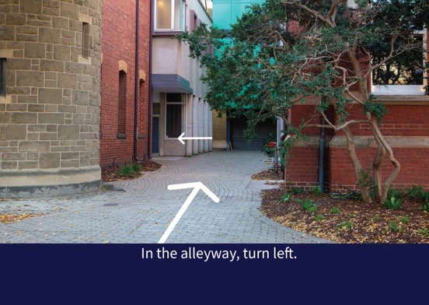
Step 2: In the alleyway, turn left.

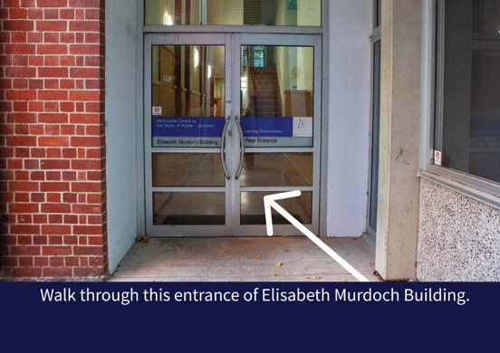
Step 3: Walk through this entrance of Elisabeth Murdoch Building.

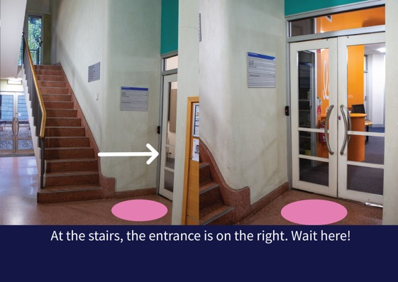
Step 4: At the stairs, the entrance is on the right. Wait here, call the producer involved.

