Level B1, 207 Bouverie St, Carlton VIC 3053
Google Maps Link
Maps.unimelb Link
Parking and Transport
Campus information Link
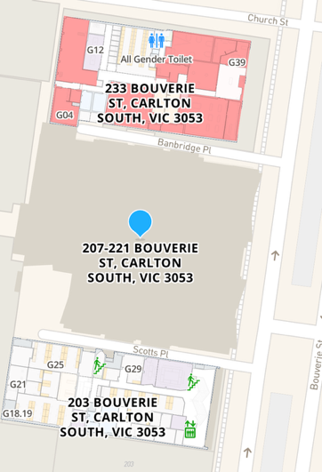
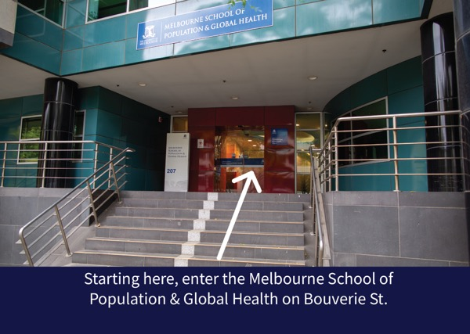Step 1: Starting here, enter the Melbourne School of Population & Global Health on Bouverie St.

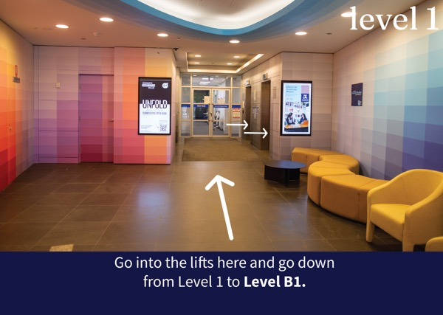Step 2: Go into the lifts here and go down from Level 1 to Level B1.

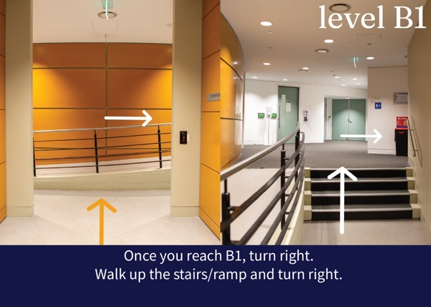Step 3: Once you reach B1, turn right. Walk up the stairs/ramp and turn right.

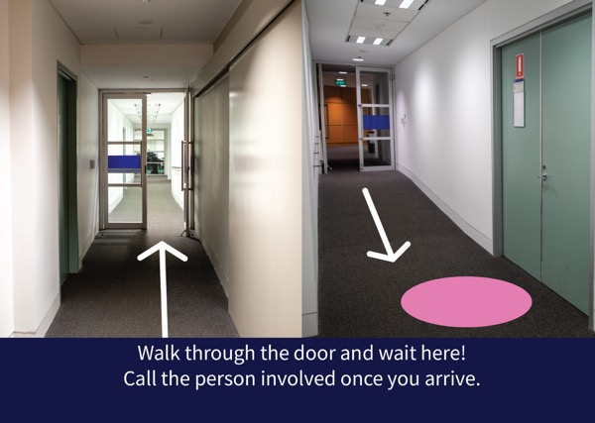Step 4: Walk through the door and wait here! Call the person involved once you arrive.

