Ground floor, Old Geology Building (South Wing), Parkville VIC 3010
Google Maps Link
Maps.unimelb Link
Parking and Transport
Campus information Link

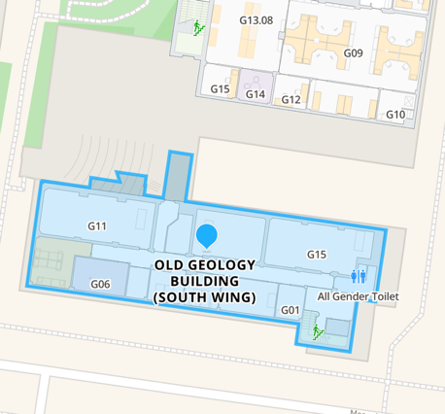

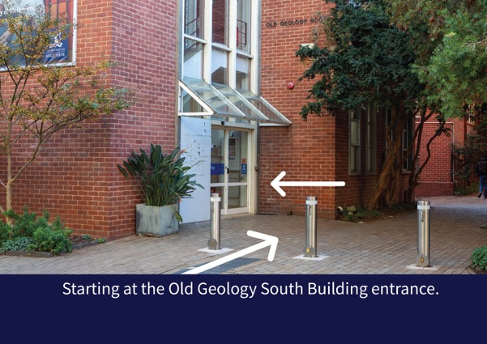Step 1: Starting at the Old Geology South Building entrance.
Opposite to St. Ali’s coffee shop.
Cross the street to find OGS entrance.

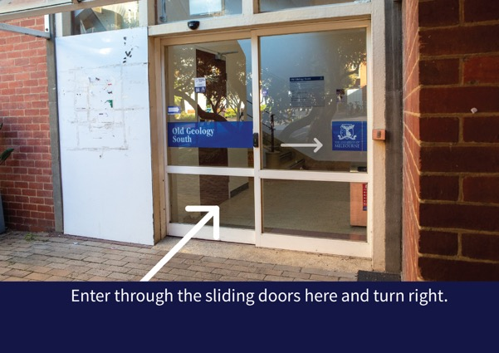Step 2: Enter through the sliding doors here and turn right.

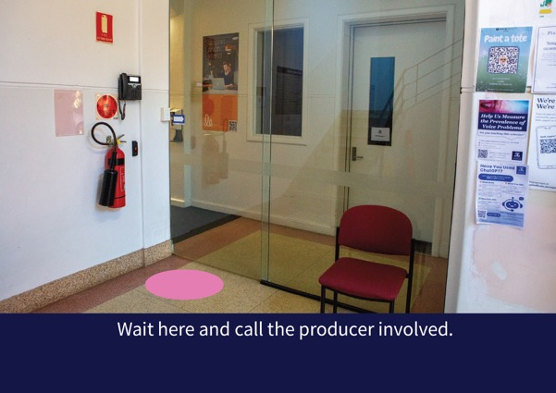Step 3: Wait here and call the producer involved.

